### SHOP HUB

**A PROJECT REPORT**

***Submitted by***

### SAILESH.S 727822TUEE134

***in partial fulfillment for the award of the degree of***

### BACHELOR OF ENGINEERING IN

**DEPARTMENT OF ELECTRICAL AND ELECTRONICS ENGINEERING**

### FEBRUARY 2023

**BONAFIDE CERTIFICATE**

Certified that this project report “**SHOP HUB”** is the bonafide work of

**“SAILESH.S”** who carried out the project work under my supervision.

#### SIGNATURE SIGNATURE

**Dr.JEYABHARATHI.D DR. LIJO JACOB**

#### SUPERVISOR HEAD OF THE DEPARTMENT

Assistant Professor, Professor,

Department of Computer Science Department of Electrical and

and Engineering Electronics and Engineering

Sri Krishna College of Technology, Sri Krishna College of Technology,

Coimbatore-641042. Coimbatore-641042.

Certified that the candidate was examined by us in the Project Work Viva Voce examination held on at Sri Krishna College of Technology, Kovaipudur, Coimbatore -641042

### INTERNAL EXAMINER EXTERNAL EXAMINER

***________________________________________ACKNOWLEDGEMENT***

### ACKNOWLEDGEMENT

First and foremost, I thank the **Almighty** for being our light and for showering his gracious blessings throughout the course of this project.

I am grateful to our beloved Dean-Academics **Dr. Manju P &** Dean-Administration **Dr. R Ramesh Kumar** for their tireless and relentless support.

I extend our sincere thanks to our Head of the Department

**Dr. Lijo Jacob Varghese** for her encouragement and inspiration.

I am greatly indebted to our Industry Mentor **Mr. Anthony Michael Sahayam** & Project guide **Dr D Jeyabharathi** Assistant Professor, Department of Computer Science and Engineering for their valuable guidance and suggestions in all aspects that aided us to ameliorate our skills.

I am thankful to all those who have directly and indirectly extended their help to us in completing this project work successfully.

# ABSTRACT



iv

## ABSTRACT

E-commerce websites are an increasingly popular way for businesses to reach consumers in the digital age. They provide customers with the convenience of shopping online, often offering a wider selection of products and services than a traditional brick-and-mortar store. E-commerce websites also allow for more personalized and targeted marketing strategies, creating a more efficient customer experience. At the core of any e-commerce website is a content management system (CMS), which is responsible for managing the site’s content, including product descriptions, images, and reviews. E-commerce websites also require payment processing systems, such as PayPal, and advanced security protocols to ensure customer data is kept safe. Additionally, the website should have a search engine optimization (SEO) strategy in place to ensure it ranks highly in search results. To ensure a successful e-commerce website, businesses should focus on having an attractive design and easy-to-navigate user interface. This should include a clear and concise product catalog, as well as an intuitive checkout process. Additionally, businesses should consider incorporating features such as product recommendations, customer reviews, and wishlists. Finally, businesses should focus on providing exceptional customer service. This should include offering assistance with product selection, providing fast and reliable.

# 

# TABLE OF CONTENTS



**TABLE OF CONTENT**

|  |  |  |
| --- | --- | --- |
| **CHAPTER.NO** | **TITLE** | **PAGE NO** |
| 1 | INTRODUCTION | 2 |
|  |  |  |
|  | 1.2 OBJECTIVE | 3 |
|  | 1.3 OVERVIEW | 4 |
| 2 | SYSTEM SPECIFICATIONS | 6 |
| 3 | PROPOSED SYSTEM | 7 |
|  | 3.1 PROPOSED SYSTEM | 8 |
|  | 3.2 ADVANTAGES | 9 |
|  |  |  |
| 4 | METHODOLOGIES | 10 |
|  | 4.1 HOME PAGE | 11 |
|  | 4.2 LOGIN PAGE | 12 |
|  | 4.3 SIGN UP PAGE | 13 |
|  | 4.4 EXPLORE PAGE | 14 |
|  | 4.5 PRODUCT PAGE | 14 |
|  | 4.6 PAYMENT PAGE | 14 |
|  | 4.7 PAYMENT SUCCESSFUL PAGE | 14 |
|  | 4.8 CONTACT PAGE | 14 |
|  | 4.9 ABOUT PAGE | 14 |
|  |  |  |
| 5 | IMPLEMENTATION AND RESULT | 15 |
| 6 | CONCLUSION AND FUTURE SCOPE | 54 |
|  | 7.1 CONCLUSION | 55 |
|  | 7.2 FUTURE SCOPE | 55 |
| 7 | REFERENCES | 56 |

# LIST OF FIGURES



**LIST OF FIGURES**

|  |  |  |
| --- | --- | --- |
| **Figure No** | **TITLE** | **Page No** |
| 4.1 | Process flow diagram | 11 |
| 4.2 | Login Page flow diagram | 12 |
| 4.3 | Signup Page flow diagram | 13 |
| 5.1 | Home Page | 16 |
| 5.2 | Login Page | 17 |
| 5.3 | Sign up Page | 18 |
| 5.4 | Explore Page | 19 |
| 5.5 | Product Page | 20 |
| 5.6 | Payment Page | 21 |
| 5.7 | Payment Successful Page | 22 |
| 5.8 | Contact Page | 23 |
| 5.9 | About Page | 24 |

# LIST OF ABBREVIATIONS



### LIST OF ABBREVIATIONS

#### ABBREVIATION ACRONYMS

**HTML** HYPERTEXT MARKUP LANGUAGE

**CSS** CASCADING STYLESHEET

**JS** JAVASCRIPT

# INTRODUCTION



## CHAPTER 1 INTRODUCTION

Welcome to our online shopping website! We offer a wide variety of products at the best prices. Our website is designed to make shopping easy and enjoyable. We have a vast selection of smartphones. Our user-friendly website allows you to browse our products quickly and easily, with filters to help you narrow down the selection based on your budget and preferences.We stock hundreds of brands and products, including the limited and special edition smartphones and hard-to-find items. We also have regular sales and discounts to ensure that you get the best deal possible. We are committed to providing excellent customer service and strive to ensure that our customers are happy with every purchase.We use secure payment methods and a reliable delivery service to ensure that your orders arrive safely and on time. We also offer a no-questions-asked returns policy to ensure that you are completely satisfied with your purchase. We want you to be confident in your shopping experience and guarantee that you will be satisfied with our products and services. So don't think start visiting our online shopping website. We hope you find what you are looking for and enjoy a pleasant shopping experience

### OBJECTIVE

To create an easy-to-use, reliable, and secure online shopping experience that provides customers with a wide variety of smartphone products at competitive prices. And lifetime Customer support.

### OVERVIEW

A shopping website is an online platform that allows users to browse and purchase products or services. It is the digital equivalent of a physical store, allowing customers to view and select items to purchase. The shopping website typically contains product information, photos, reviews, and other details to help customers make informed decisions.Most shopping websites also provide a secure checkout process, allowing customers to pay for their purchases quickly and securely.Shopping websites may also offer subscription services, loyalty programs, and other features to create a more personalized shopping experience.

# 

# SYSTEM SPECIFICATION



## CHAPTER 2 SYSTEM SPECIFICATION

### VS-code (Visual Studio code):

Visual Studio Visual Studio was the main integrated development environment (IDE) for developing application. Visual Studio Code, also commonly referred to as VS Code, is a source-code editor made by Microsoft with the Electron Framework, for Windows, Linux and macOS. Features include support for debugging, syntax highlighting, intelligent code completion, snippets, code refactoring, and embedded Git.

### 2.2 HTML (Hyper Text Markup Language):

HTML refers to Hyper Text Markup Language.HTML is used to structure a web page and its content HTML is not a programming language. All HTML documents must start with a document type declaration: <!DOCTYPE html>.The visible part of the HTML document is between <body> and</body>.The four required tags in HTML are HTML, title, head, and body. HTML helps in creating web pages and web applications.

.

### CSS (Cascading Style Sheets):

CSS is used along with HTML in order to style the webpage. There are three types of CSS-editing:

* + - Inline CSS – Styles the HTML page in the element itself.
    - Internal CSS – Styles the HTML page within the *<head></head>* tag.
* External CSS – Uses an external CSS file to style the html page. Among these three types, the internal and external CSS are preferred most.

### JS(JavaScript):

In order to make a html page responsive, JavaScript is used. JavaScript has the ability to manipulate the inner HTML elements. Similar to CSS there are three types of JS.

* Inline JS-Using JS within the HTML tags
* Internal JS-Using JS in the *<script></script>*tag in the head or body of HTML
* External JS-Using a separate JS file.

# PROPOSED SYSTEM



## CHAPTER 3 PROPOSED SYSTEM

This chapter gives a small description about the proposed idea behind the development of my website.

### PROPOSED SYSTEM

A proposed system of a shopping website included the following components:

User Registration: The website should have a user registration feature where customers can create an account with their personal data, such as name, address, contact number, email address, etc. Payment Gateway: The website should have a secure payment gateway for customers to make payments. Product Categories: The website should have product categories to make it easier for customers to find the products they are looking for.Product Reviews: The website should have a product review feature, where customers can leave reviews and ratings on products.

Customer Support: The website should have a customer support team to help customers with any queries they may have.Security: The website should have secure protocols in place to ensure the safety of customers' data.Overall, a proposed system for a shopping website would be designed to provide a comprehensive and user-friendly platform for customers to view their product.

### 

### 3.2 ADVANTAGES

The advantages of a shopping website include increased visibility and exposure, convenient and accessible information, the customer feedback and reviews, increased brand awareness, and data-driven decision making.

Convenience: Shopping online is extremely convenient for customers as they can shop anytime and from anywhere. Variety: Online stores often have a wider variety of products than brick and mortar stores. Price: Online stores can offer lower prices due to lower overhead costs.Speed: Online shopping is much faster than traditional shopping. Comparisons: Shopping online makes it easier to compare prices and features of different products. Reviews: Customers can read reviews from other customers before making a purchase decision. Discounts: Online stores often offer discounts or special deals that are not available in physical stores.Easy Returns: Online stores often offer easy return policies that allow customers to return items with ease.

# METHODOLOGIES



## CHAPTER 4 METHODOLOGIES

This chapter gives a small description about how our system works.

### 4.1 HOME PAGE

**HOME**

**PRODUCT**

**OVERVIEW**

**SIGN IN**

**PACKAGES**

**PAYMENT**

**ORDER**

**PLACED**

Fig 4.1 PROCESS FLOW DIAGRAM

### 4.2.LOGIN PAGE

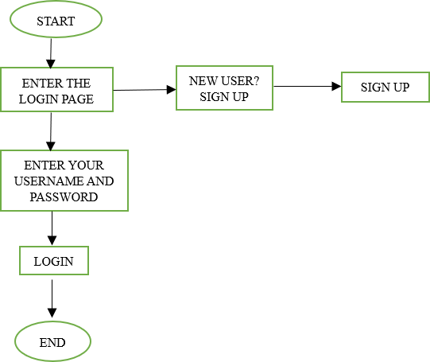

ENTER THE LOGIN PAGE PAGE

START

ENTER USERNAME AND PASSWORD

SIGN UP

NEW USER? SIGN UP

END

LOGIN

Fig 4.2. LOGIN PAGE FLOWCHART

In this page we will be asking about the username and password of the user. Firstly, the website validates the user inputs. It verifies the username and password by checking it with the usernames and passwords stored in the local storage when the user creates an account on the website.

### 4.3 SIGNUP PAGE FLOWCHART

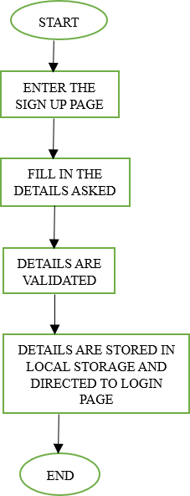

DIRECTED TO LOGIN

PAGE

END

START

ENTER THE

SIGN UP PAGE

FILL IN THE

DETAILS ASKED

DETAILS ARE

VALIDATED

Fig 4.3 SIGNUP PAGE FLOWCHART

This page asks users about the basic details of the user to create an account. This page asks for details like username, password, email id, phone number. After the user enters the details, these details are then validated by our code . If all details are correct, then the user is then directed to the login page.

### 4.4. EXPLORE PAGE

If you have forgotten your password, you can reset through this page. It directs to login page.

### 4.5. PRODUCT PAGE

A product page on a shopping website is a page dedicated to a specific product that contains all the information a customer needs to make a purchase decision. This page typically features product images, pricing information, product descriptions, customer reviews, and product specifications.

### 4.6. PAYMENT PAGE

The payment page of a shopping website is the page where customers enter their payment information to complete the purchase. This page includes the payment form, payment methods, payment gateway, and the payment confirmation page. It is important for the payment page of a shopping website to be secure and user-friendly.

### 4.7. PAYMENT SUCCESSFUL PAGE

In payment successful page, the website shows the user that they have been successfully placed the order in the e-commerce website.

### 4.8. CONTACT PAGE

In contact page, if you have any questions, comments or concerns about the website, products or services. You can contact them by filling out the form in the page, or by emailing them.

### 4.9. ABOUT PAGE

In the about page, the developer of the website or founder of the company tells about their page and their company.

# IMPLEMENTATION AND RESULT



**CHAPTER 5 IMPLEMENTATION AND RESULT**

This chapter gives a description about the output that we produced by developing the website of our idea.

### HOME

A home page is the primary web page that a visitor will view when they navigate to a website via a search engine, and it may also function as a landing page to attract visitors.

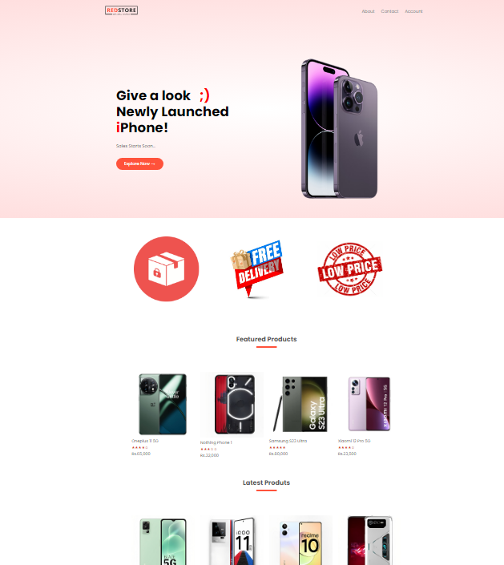

Fig 5.1 HOME PAGE

### 5.2LOGIN

When User enters my website, you will be asked about your login details like email id and password. The login details will be verified with the details given while the user creates an account.

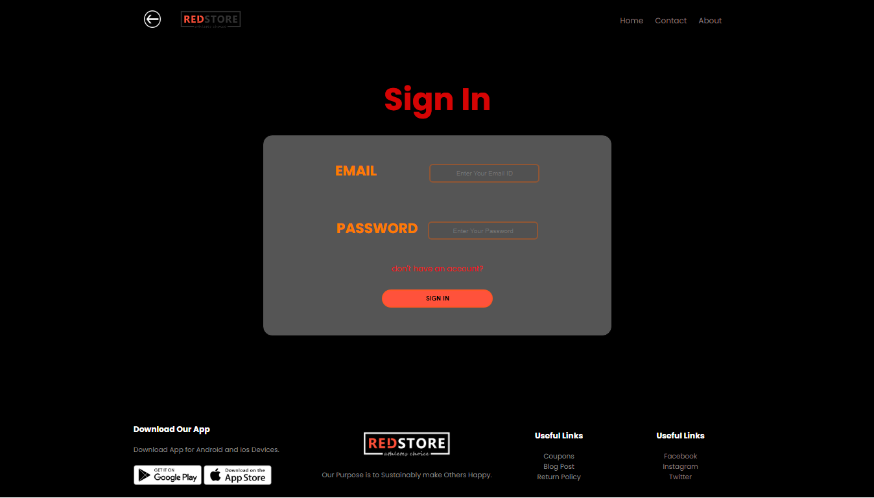

Fig 5.2 LOGIN PAGE

**5.3SIGN UP**

If a user doesn’t have an account on the website, User can use a component named create new account available in the login page. When the user clicks on that he will be redirected to the signup page. In sign up he should fill up his email id, password and phone number. These inputs will be validated.

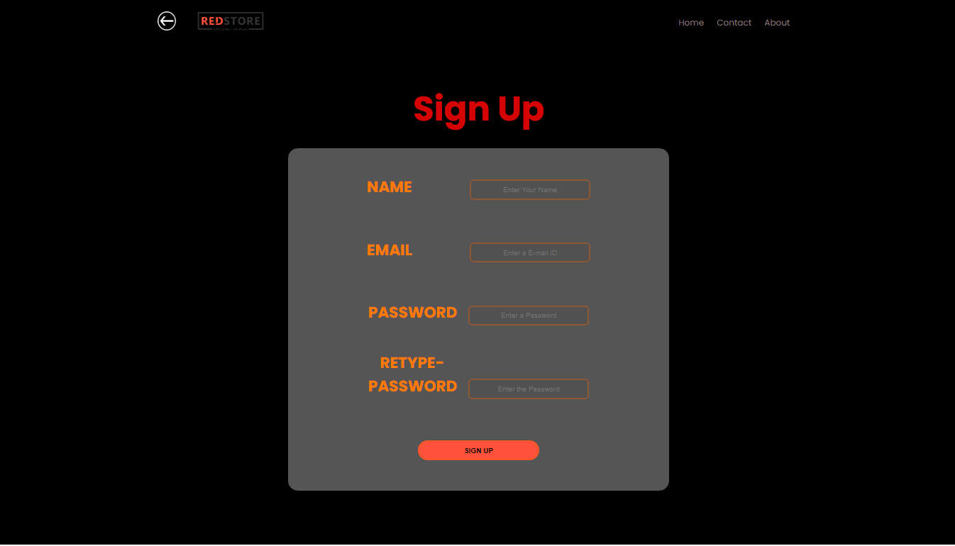

Fig 5.3 SIGN UP

### EXPLORE PAGE

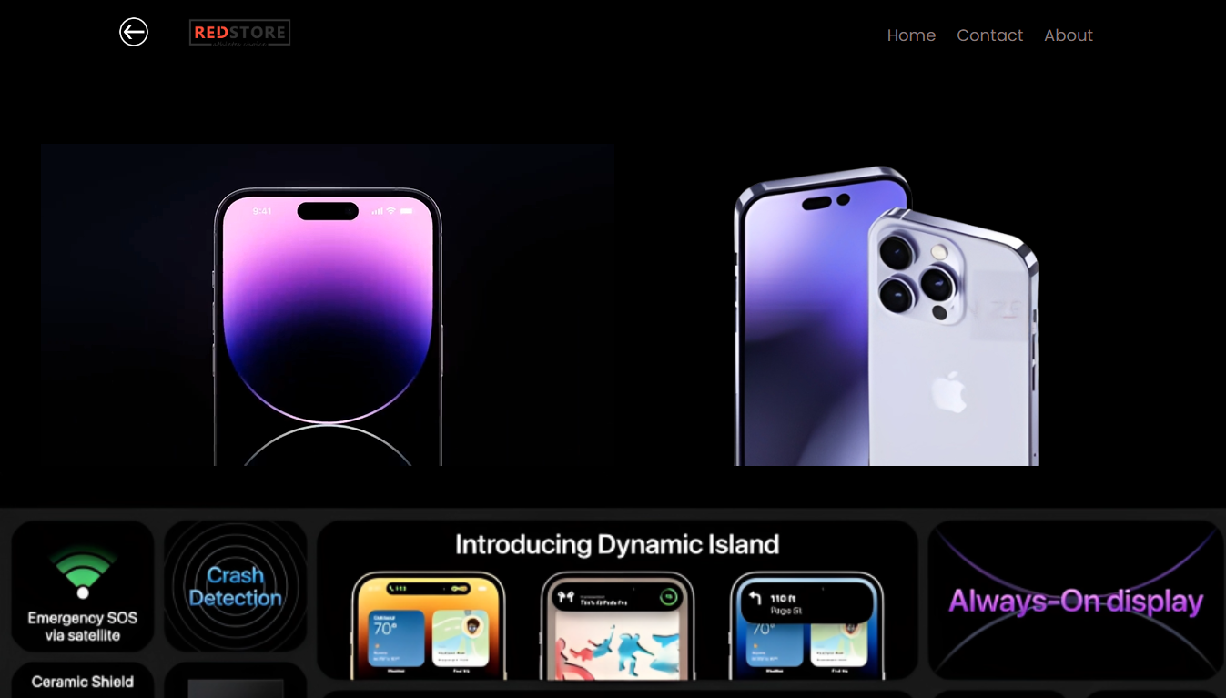

Fig 5. EXPLORE PAGE

### PRODUCT PAGE

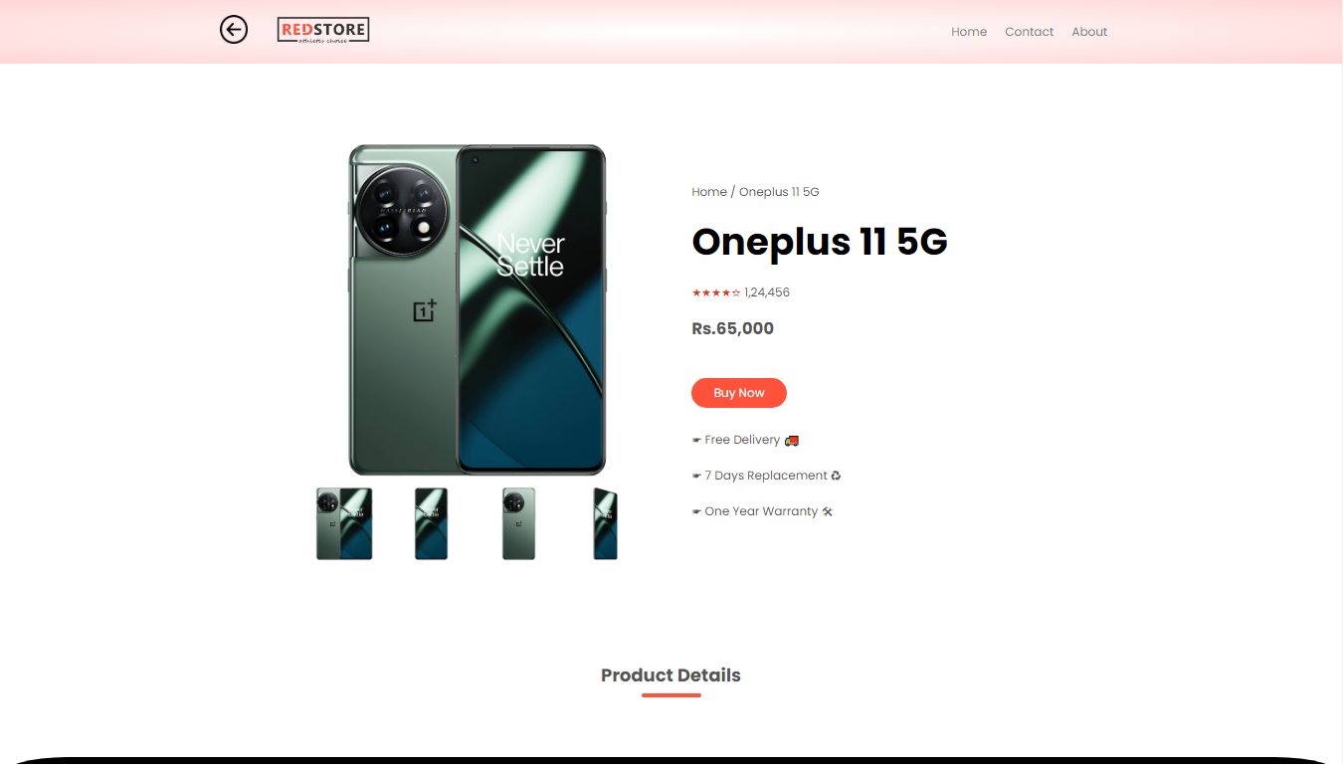

Fig 5.6 PRODUCT PAGE

### PAYMENT PAGE

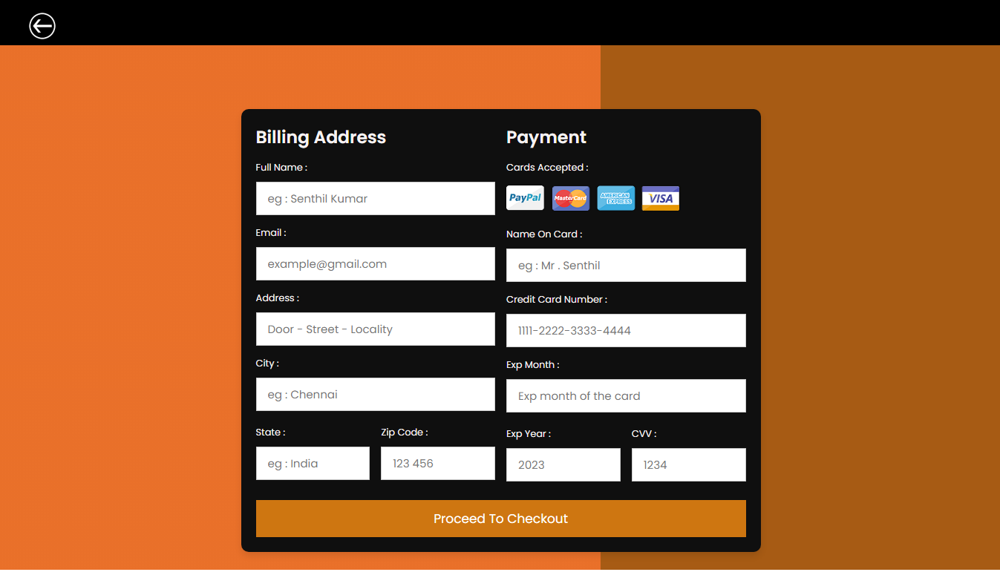

Fig 5.7 PAYMENT PAGE

### PAYMENT SUCCESSFUL PAGE

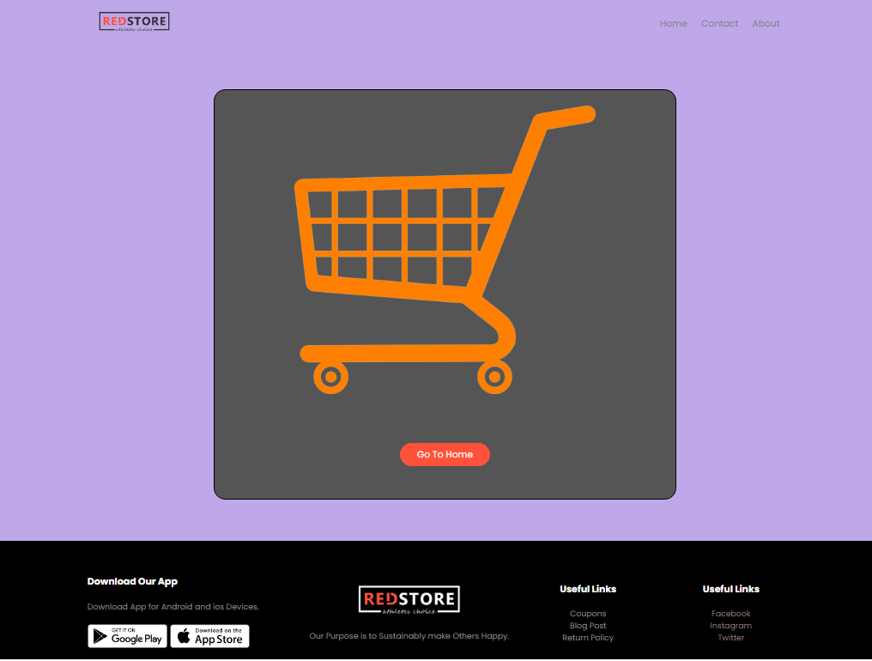

Fig 5.8 PAYMENT SUCCESSFUL PAGE

### CONTACT PAGE

A comment form is a way to collect opinions about my website service. The goal is to gain a better understanding of the overall customer experience so that I can identify areas for improvement. Also, the customers can ask their questions/queries in this page).

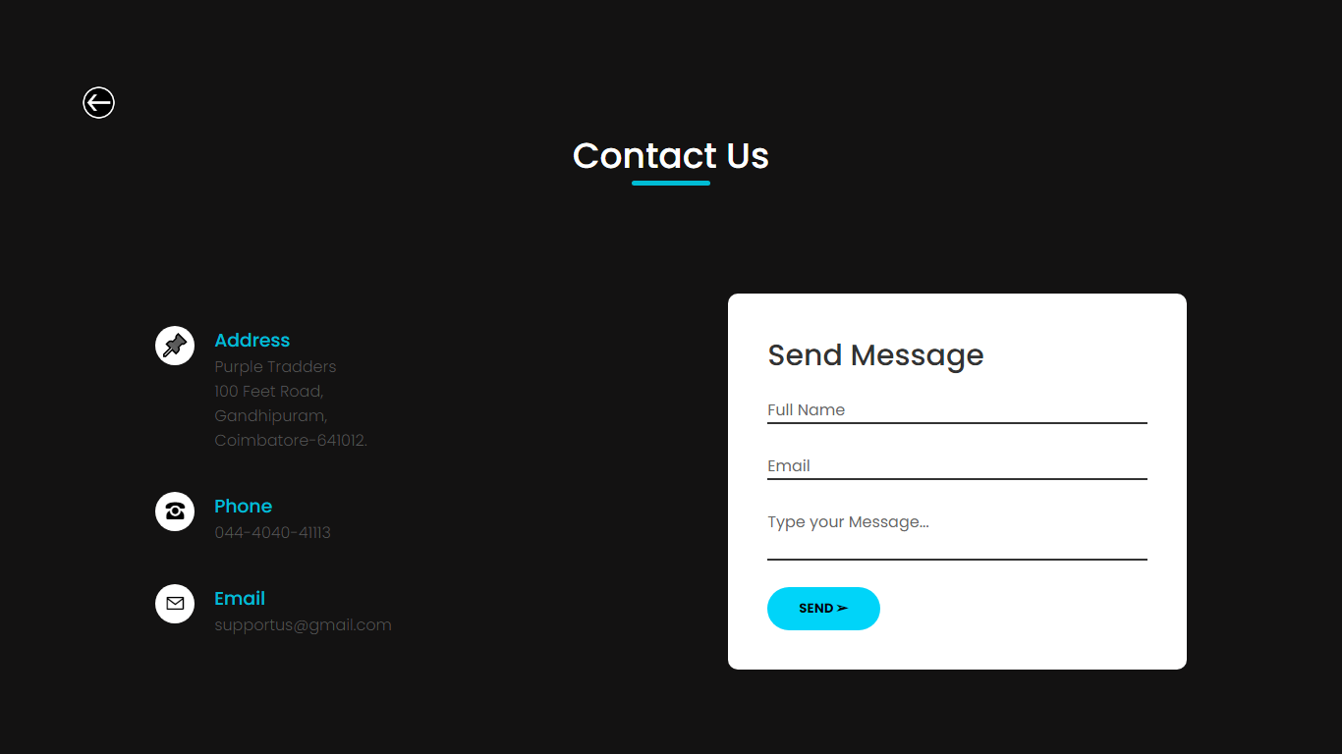

Fig 5.9 CONTUCT PAGE

### ABOUT

This page is a subpage of comment page. Once the customer filled the comment form and clicks post comment button, this Thank you page displays.

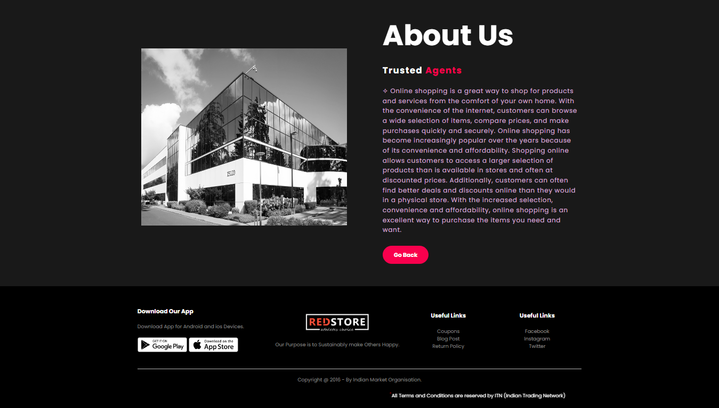

Fig 5.10 ABOUT PAGE

### CODING

### Home:

<!DOCTYPE html>

<html>

<head>

<title>My Shopping Website</title>

<meta charset="UTF-8">

<meta name="viewport" content="width=device-width, initial-scale=1.0">

<meta name="viewport" content="width=device-width, initial-scale=1.0">

<link rel="stylesheet" href="style.css">

<link rel="preconnect" href="https://fonts.googleapis.com">

<link rel="preconnect" href="https://fonts.gstatic.com" crossorigin>

<link href="https://fonts.googleapis.com/css2?family=Poppins:wght@300;400;500;600;700&display=swap" rel="stylesheet">

</head>

<body>

<div class="header">

<div class="container">

<div class="navbar">

<div class="logo">

<img src="images/logo.png" width="125px">

</div>

<nav>

<ul id="MenuItems">

<li><a href="about.html">About</a></li>

<li><a href="contact.html">Contact</a></li>

<li><a href="Login.html">Account</a></li>

</ul>

</nav>

<img src="images/menu.png" class="menu-icon" onclick="menutoggle()">

</div>

<div class="row">

<div class="col-2">

<h1> Give a look <span style="color: red;"> &nbsp; ;)</span><br>Newly Launched <span style="color: red;">i</span>Phone!</h1>

<p>Sales Starts Soon...</p>

<a href="i-explore.html" class="btn">Explore Now &#8594</a>

</div>

<div class="col-2">

<img src="images/image1.png">

</div>

</div>

</div>

</div>

<!-----------brands---------->

<div class="brands">

<div class="small-container">

<div class="row">

<div class="col-5>

<a href="https://www.oppo.com/in/?gclid=Cj0KCQiAxbefBhDfARIsAL4XLRq0-JNusZ2VLvqCt5wCx6rGwoLKQ3eWA1Gq1RE9XUYJpT9O9mtnxlEaAg_lEALw_wcB"><img src="images/logo-oppo.png"></a>

</div>

</div>

</div>

</div>

<!--------------js for menu------------>

<script>

var MenuItems = document.getElementById("MenuItems");

MenuItems.style.maxHeight = "0px";

function menutoggle(){

if(MenuItems.style.maxHeight == "0px")

{

MenuItems.style.maxHeight = "200px";

}

else

{

MenuItems.style.maxHeight = "0px";

}

}

</script>

</body>

</html>

**Login:**

<!DOCTYPE html>

<html>

<head>

<title>Product</title>

<meta charset="UTF-8">

<meta name="viewport" content="width=device-width, initial-scale=1.0">

<meta name="viewport" content="width=device-width, initial-scale=1.0">

<link rel="stylesheet" href="style.css">

<link rel="preconnect" href="https://fonts.googleapis.com">

<link rel="preconnect" href="https://fonts.gstatic.com" crossorigin>

<link href="https://fonts.googleapis.com/css2?family=Poppins:wght@300;400;500;600;700&display=swap" rel="stylesheet">

</head>

<body style="background-color: rgb(0, 0, 0);">

<!------ <div class="header">--------->

<div class="container">

<div class="navbar">

<div class="logo">

<a href="main.html"><img src="images/backwhite.png" width="38px"></a> &nbsp; &nbsp; &nbsp; &nbsp;

<img src="images/logo.png" width="125px">

</div>

<nav>

<ul id="MenuItems">

<li><a href="main.html">Home</a></li>

<li><a href="contact.html">Contact</a></li>

<li><a href="about.html">About</a></li>

</ul>

</nav>

<img src="images/menu.png" class="menu-icon" onclick="menutoggle()">

</div>

</div>

<!------</div>------>

<br><br><br>

<!-----------sign in----------->

<center>

<p style="color:rgba(253, 5, 5, 0.863);font-weight:bold;font-size:4rem;">

Sign In

</p><br>

<form action="payment.html">

<div class="datacontainer">

<br>

</center>

<br><br><br><br><br>

<!--------------js for menu------------>

<script>

var MenuItems = document.getElementById("MenuItems");

MenuItems.style.maxHeight = "0px";

function menutoggle(){

if(MenuItems.style.maxHeight == "0px")

{

MenuItems.style.maxHeight = "200px";

}

else

{

MenuItems.style.maxHeight = "0px";

}

}

</script>

</body>

</html>

**Sign up page:**

<!DOCTYPE html>

<html>

<head>

<title>Product</title>

<meta charset="UTF-8">

<meta name="viewport" content="width=device-width, initial-scale=1.0">

<meta name="viewport" content="width=device-width, initial-scale=1.0">

<link rel="stylesheet" href="style.css">

<link rel="preconnect" href="https://fonts.googleapis.com">

<link rel="preconnect" href="https://fonts.gstatic.com" crossorigin>

<link href="https://fonts.googleapis.com/css2?family=Poppins:wght@300;400;500;600;700&display=swap" rel="stylesheet">

</head>

<body style="background-color: rgb(0, 0, 0);">

<!------ <div class="header">--------->

<div class="container">

<div class="navbar">

<div class="logo">

<a href="Login.html"><img src="images/backwhite.png" width="38px"></a> &nbsp; &nbsp; &nbsp; &nbsp;

<img src="images/logo.png" width="125px">

</div>

<nav>

<ul id="MenuItems">

<li><a href="main.html">Home</a></li>

<li><a href="contact.html">Contact</a></li>

<li><a href="about.html">About</a></li>

</ul>

</nav>

<img src="images/menu.png" class="menu-icon" onclick="menutoggle()">

</div>

</div>

<!------</div>------>

<br><br><br>

<!--------------js for menu------------>

<script>

var MenuItems = document.getElementById("MenuItems");

MenuItems.style.maxHeight = "0px";

function menutoggle(){

if(MenuItems.style.maxHeight == "0px")

{

MenuItems.style.maxHeight = "200px";

}

else

{

MenuItems.style.maxHeight = "0px";

}

}

</script>

</body>

</html>

**Explore page:**

<!DOCTYPE html>

<html>

<head>

<title>Product</title>

<meta charset="UTF-8">

<meta name="viewport" content="width=device-width, initial-scale=1.0">

<meta name="viewport" content="width=device-width, initial-scale=1.0">

<link rel="stylesheet" href="style.css">

<link rel="preconnect" href="https://fonts.googleapis.com">

<link rel="preconnect" href=<https://fonts.gstatic.com>>

href="https://fonts.googleapis.com/css2?family=Poppins:wght@300;400;500;600;700&display=swap" rel="stylesheet">

</head>

<body style="background-color: rgb(0, 0, 0);"><!------ <div class="header">--------->

<div class="container">

<div class="navbar">

<div class="logo">

<a href="main.html"><img src="images/backwhite.png" width="38px"></a> &nbsp; &nbsp; &nbsp; &nbsp;

<img src="images/logo.png" width="125px">

</div>

<nav>

<ul id="MenuItems">

<li><a href="main.html">Home</a></li>

<li><a href="contact.html">Contact</a></li>

<li><a href="about.html">About</a></li>

</ul>

</nav>

<img src="images/menu.png" class="menu-icon" onclick="menutoggle()">

</div>

</div>

<!------</div>------>

<br><br><br>

<video autoplay="" controls="" loop="" width="50%">

<source src="images/video.mp4" type="video/mp4">

</video>

<img src="images/apple-bg-3.png" width="100%"><br><br><br><br><br><br><br><br><br>

<img src="images/apple-bg-4.png" width="100%"><br><br><br><br><br>

<div>

<\html>

<!--------------js for menu------------>

<script>

var MenuItems = document.getElementById("MenuItems");

MenuItems.style.maxHeight = "0px";

function menutoggle(){

if(MenuItems.style.maxHeight == "0px")

{

MenuItems.style.maxHeight = "200px";

}

else

{

MenuItems.style.maxHeight = "0px";

}

}

</script>

</body>

</html>

**Product Page:**

<!DOCTYPE html>

<html>

<head>

<title>Product1</title>

<meta charset="UTF-8">

<meta name="viewport" content="width=device-width, initial-scale=1.0">

<meta name="viewport" content="width=device-width, initial-scale=1.0">

<link rel="stylesheet" href="style.css">

<link rel="preconnect" href="https://fonts.googleapis.com">

<link rel="preconnect" href="https://fonts.gstatic.com" crossorigin>

<link href="https://fonts.googleapis.com/css2?family=Poppins:wght@300;400;500;600;700&display=swap" rel="stylesheet">

</head>

<body>

<div class="header">

<div class="container">

<div class="navbar">

<div class="logo">

<a href="main.html"><img src="images/back.png" width="38px"></a> &nbsp; &nbsp; &nbsp; &nbsp;

<img src="images/logo.png" width="125px">

</div>

<nav>

<ul id="MenuItems">

<li><a href="main.html">Home</a></li>

<li><a href="contact.html">Contact</a></li>

<li><a href="about.html">About</a></li>

</ul>

</nav>

<img src="images/menu.png" class="menu-icon" onclick="menutoggle()">

</div>

</div>

</div>

<div class="footer-col-4">

<h3>Useful Links</h3>

<ul>

<a href="https://www.facebook.com/login/"><li>Facebook</li></a>

<a href="https://www.instagram.com/"><li>Instagram</li></a>

<a

</ul>

</div>

</div>

<hr>

</div>

<!--------------js for menu------------>

<script>

var MenuItems = document.getElementById("MenuItems");

MenuItems.style.maxHeight = "0px";

function menutoggle(){

if(MenuItems.style.maxHeight == "0px")

{

MenuItems.style.maxHeight = "200px";

}

else

{

MenuItems.style.maxHeight = "0px";

}

}

</body>

</html>

**Payment Page:**

<!DOCTYPE html>

<html lang="en">

<head>

<meta charset="UTF-8">

<meta http-equiv="X-UA-Compatible" content="IE=edge">

<meta name="viewport" content="width=device-width, initial-scale=1.0">

<link rel="stylesheet" href="payment-style.css">

</head>

<body>

<div class="margin-top">

<a href="main.html"><img src="images/backwhite.png" width="38px"></a>

</div>

<div class="container">

<form action="ordered.html">

<div class="row">

<div class="col">

<h3 class="title">billing address</h3>

<div class="inputBox">

<span>full name :</span>

<input type="text" placeholder="eg : Senthil Kumar" required>

</div>

<div class="inputBox">

<span>email :</span>

<input type="email" placeholder="example@gmail.com" required>

</div>

<div class="inputBox">

<span>address :</span>

<input type="text" placeholder="Door - Street - Locality" required>

</div>

<div class="inputBox">

<span>city :</span>

<input type="text" placeholder="eg : Chennai" required>

</div>>

<div class="inputBox">

<span>name on card :</span>

<input type="text" placeholder="eg : Mr . Senthil" required>

</div>

<div class="inputBox">

<span>credit card number :</span>

<input type="number" placeholder="1111-2222-3333-4444" required>

</div>

<div class="inputBox">

<span>exp month :</span>

<input type="text" placeholder="Exp month of the card" required>

</div>

<div class="flex">

<div class="inputBox">

<span>exp year :</span>

<input type="number" placeholder="2023" required>

</div>

<div class="inputBox">

<span>CVV :</span>

<input type="text" placeholder="1234" required>

</div>

</div>

</div>

</div>

<input type="submit" value="proceed to checkout" class="submit-btn">

</form>

</div>

</body>

</html>

**Payment Successful page:**

<!DOCTYPE html>

<html>

<head>

<title>Product</title>

<meta charset="UTF-8">

<meta name="viewport" content="width=device-width, initial-scale=1.0">

<meta name="viewport" content="width=device-width, initial-scale=1.0">

<link rel="stylesheet" href="style.css">

<link rel="preconnect" href="https://fonts.googleapis.com">

<link rel="preconnect" href="https://fonts.gstatic.com" crossorigin>

<link href="https://fonts.googleapis.com/css2?family=Poppins:wght@300;400;500;600;700&display=swap" rel="stylesheet">

</head>

<body style="background-color: #9470db9a">

<!------ <div class="header">--------->

<div class="container">

<div class="navbar">

<div class="logo">

<img src="images/logo.png" width="125px">

</div>

<nav>

<ul id="MenuItems">

<li><a href="main.html">Home</a></li>

<li><a href="contact.html">Contact</a></li>

<li><a href="about.html">About</a></li>

</ul>

</nav>

<img src="images/menu.png" class="menu-icon" onclick="menutoggle()">

</div>

</div>

<!-------</div>--------->

<br><br><br>

<!-----------sign in----------->

<center>

<!--------------js for menu------------>

<script>

var MenuItems = document.getElementById("MenuItems");

MenuItems.style.maxHeight = "0px";

function menutoggle(){

if(MenuItems.style.maxHeight == "0px")

{

MenuItems.style.maxHeight = "200px";

}

else

{

MenuItems.style.maxHeight = "0px";

}

}

</script>

</body>

</html>

**Contact page:**

<!DOCTYPE html>

<html lang="en">

<head>

<meta charset="UTF-8">

<meta http-equiv="X-UA-Compatible" content="IE=edge">

<meta name="viewport" content="width=device-width, initial-scale=1.0">

<title>Contact</title>

<link rel="preconnect" href="https://fonts.googleapis.com">

<link rel="preconnect" href="https://fonts.gstatic.com" crossorigin>

</div>

<div class="box">

<div class="icon">&#9742;</div>

<div class="text">

<h3>Phone</h3>

<p> <a href="tel:+91">044-4040-41113</a></p>

</div>

</div>

<div class="box">

<div class="icon">&#9993;</div>

<div class="text">

<h3>Email</h3>

<p><a href="mailto:22eee.jeevanprasath.d@skct.edu.in">supportus@gmail.com</a></p>

</div>

</div>

</div>

<div class="contactForm">

<form style = "color:rgba(244, 255, 234, 0.962);" action ="contact2.html" target = "_blank" autocomplete="on">

<h2>Send Message</h2>

<div class="inputBox">

<input type="text" name="" required>

<span>Full Name</span>

</div>

<div class="inputBox">

<input type="text" name="" required>

<span>Email</span>

</div>

<div class="inputBox">

<textarea required></textarea>

<span>Type your Message...</span>

</div>

<div class="inputBox">

<button style="color:rgb(3, 3, 3);"oneclick="document.location=''">SEND &#10146;</button>

</div>

</form>

</div>

</div>

</section>

</body>

</html>

**About page:**

<!DOCTYPE html>

<html lang="en">

<head>

<meta charset="UTF-8">

<meta http-equiv="X-UA-Compatible" content="IE=edge">

<meta name="viewport" content="width=device-width, initial-scale=1.0">

<title>About</title>

<link rel="stylesheet" href="about-style.css">

<link rel="preconnect" href="https://fonts.googleapis.com">

<link rel="preconnect" href="https://fonts.gstatic.com" crossorigin>

<link href="https://fonts.googleapis.com/css2?family=Poppins:wght@300;400;500;600;700&display=swap" rel="stylesheet">

</head>

<body>

<section class="about">

<div class="main">

<img src="images/about.png">

<div class="about-text">

<h1>About Us</h1>

<h5>Trusted <span> Agents</span></h5>

<a href="main.html" class="btn">Go Back</a>

</div>

</div>

</section>

<!-----------footer----------->

<div class="footer">

<div class="container">

<div class="row">

<div class="footer-col-1">

<h3>Download Our App</h3>

<p>Download App for Android and ios Devices.</p>

<div class="app-logo">

<a href="https://www.apple.com/in/app-store/"><img src="images/app-store.png"></a>

</div>

</div>

<div class="footer-col-2">

<img src="images/logo-white.png">

<p>Our Purpose is to Sustainably make Others Happy.</p>

</div>

<div class="footer-col-3">

<h3>Useful Links</h3>

<ul>

<li>Coupons</li>

<li>Blog Post</li>

<li>Return Policy</li>

</ul>

</div>

<div class="footer-col-4">

<h3>Useful Links</h3>

<ul>

<a href="https://www.facebook.com/login/"><li>Facebook</li></a>

<a href="https://www.instagram.com/"><li>Instagram</li></a>

<a href="https://twitter.com/i/flow/login?input_flow_data=%7B%22requested_variant%22%3A%22eyJsYW5nIjoiZW4ifQ%3D%3D%22%7D"><li>Twitter</li></a>

</ul>

</div>

</div>

<hr>

<p class="copyright">Copyright @ 2016 - By Indian Market Organisation.</p> <br>

<marquee><p style="color:rgb(255, 255, 255)"><sup style="color:red">*</sup>All Terms and Conditions are reserved by ITN (Indian Trading Network)</p></marquee><br>

</div>

</div>

</body>

</html>

# 

# 

# CONCLUSION



## CHAPTER 6

## CONCLUSION

This chapter talks about the conclusion that anyone can drive from the project and the learning we learnt by taking over this project.

### CONCLUSION

The completion of the “**SHOPPING**” website project is an important milestone for me. I have worked hard to build a website that is easy to use, secure, and fulfills the needs of my customers. I have provided my customers with a fast, reliable, and secured delivery. I am proud of the website I have created. I have been able to make the website user-friendly. Overall, I am proud of the work I have done on the “**SHOPPING**” website project.

### FUTURE SCOPE

With digitation, the customer behavior is modified from trusting their local bakery shops to the mouth-watering, beautiful flavors available and every day created by the professional chefs. Consumers have learned to extravagant their taste buds and ‘sweet’ is no longer just sweet and ‘bakery’ is no longer just loaves of bread anymore! Bakery products are food products that involve several ingredients, but more importantly, the food products involve baking in the oven.

**Invest in your own bakery shop**: Entrepreneur opportunities is one of the best career prospects for a bakery professional and investing in a bakery benefit a community and can prove to be a boon for your pockets.

# REFERENCES



### REFERENCES

1. <https://fonts.google.com/>
2. <https://www.youtube.com/watch?v=yQimoqo0>
3. <https://www.youtube.com/watch?v=cce_70pxbqw>
4. https://github.com/
5. <https://www.w3schools.com/>
6. <https://www.geeksforgeeks.org/>
7. <https://getbootstrap.com/>